HTTP Request/Response Cycle for Web Dev:

Domain Name is an alias for the IP address for a host

* When a user accesses the domain name, the browser will search the users cache for the domain name
  + If returned 🡪 send request
  + If not 🡪 the domain name is sent to the ISP which then access the DNS to get the IP address for the host

After the IP address has been obtained, the client will send a http request to the IP addresses server

* Depending on the request the server will respond accordingly
* GET is an HTTP request for data from a specified source (IP Address Server)
  + GET requests can be cached
  + GET requests remain in the browser history
  + GET requests can be bookmarked
  + GET requests should never be used when dealing with sensitive data
  + GET requests have length restrictions
  + GET requests should be used only to retrieve data
* POST is a request to submit data back to the Hosts server
  + POST requests are never cached
  + POST requests do not remain in the browser history
  + POST requests cannot be bookmarked
  + POST requests have no restrictions on data length

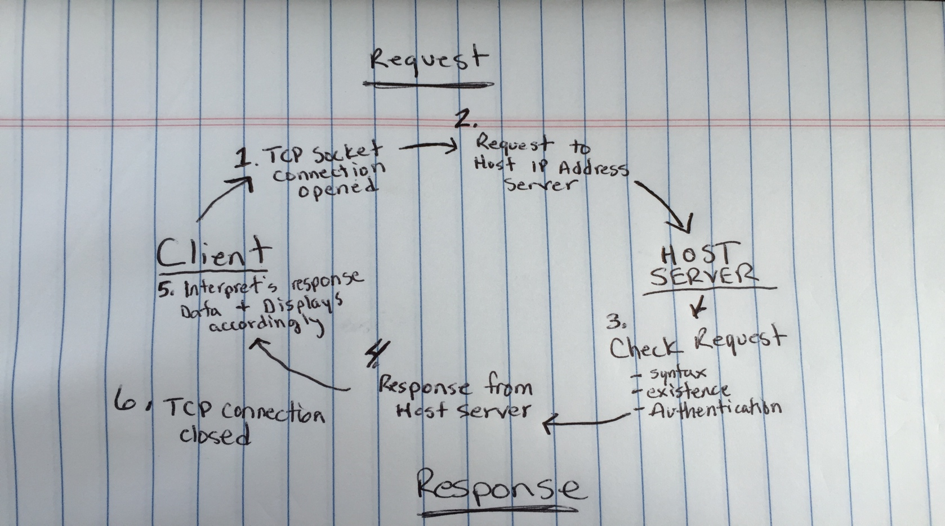

Server Code (Sinatra 🡪 Ruby)

* Processes the user input
* Displays the appropriate pages
* Builds Structure for the web app
* Interacts with DB’s

Writing a route in Sinatra:

* When writing a route, we are writing the code that will perform some action when the client sends a request to access that route
* We will render views, store information/access information, manipulate data, etc.